Programming Fundamentals

**Lab #2**

# Topics

* Object instantiation
* Using existing classes (e.g. String, Random, Math, DecimalFormat)
* Pseudorandom number generation
* String methods, formatting
* Using a debugger
* Using conditional statements
* Constructing conditions and Boolean expressions

**Concepts** new keyword dot operator

method invocation

object reference variables Strings – indexes, methods Java packages

pseudorandom number generation, seed value using static methods

formatting output

if, if-else, else statements

relational operators: ==, !=, <, >, etc.

Boolean operators: !, &&, || block statements

switch, break, default

# Exercise 1

Modify the AgeGuess program from the last lab to do the following:

* + Declare a new int variable age
  + Initialize age to a random integer between 0 and 100 (inclusive)
  + Asks the user for a guess, save the guess into the ageGuess variable
  + Display the user guess and the correct answer

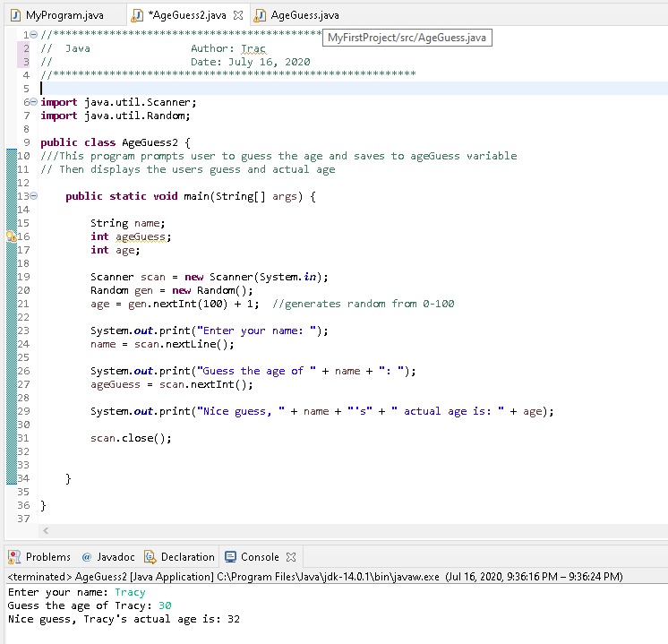

# Exercise 2

Write an application called DistCalc that reads the (𝑥, 𝑦) coordinates for two points then computes the distance between them using the following formula:

𝑑𝑖𝑠𝑡 = √(𝑥2 − 𝑥1)2 + (𝑦2 − 𝑦1)2

Display the result with three decimal places to the screen.

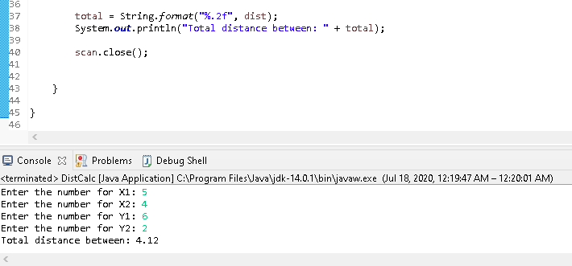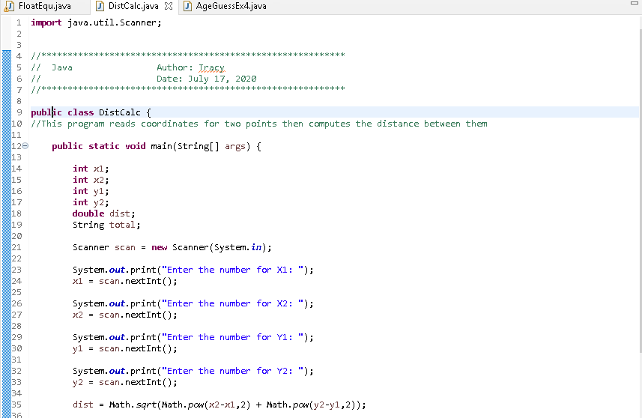

# Exercise 3

Write an application called UserNames that reads the user's first and last name (separately), then prints a string composed of the first 4 letters of the user's last name, followed by the first letter of the user's first name, followed by a random number in the range of 10 to 99 (inclusive). You can assume the first name is at least one letter long and the last name is at least 4 letters.

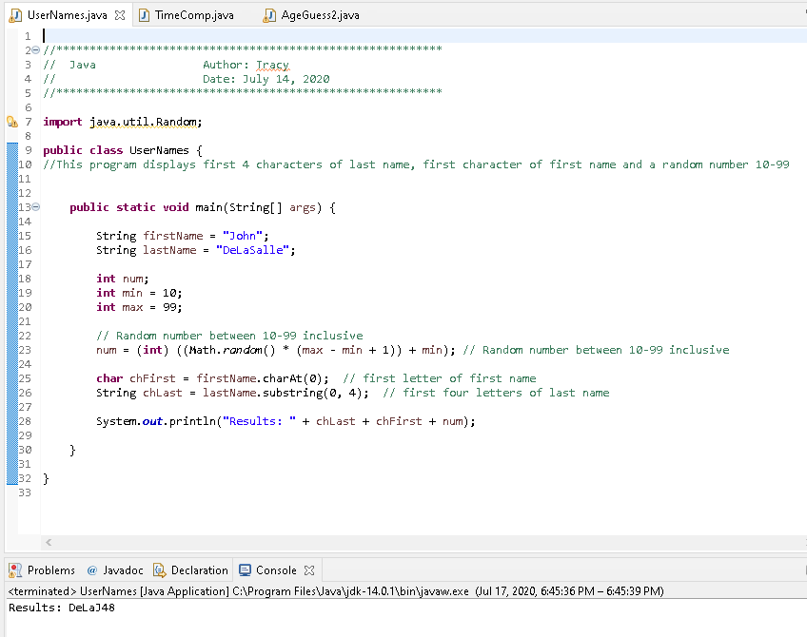

# Exercise 4

1. Modify the AgeGuess program from Ex. 1 by adding a conditional statement (if statement) to print out "You guessed wrong!" if the age and ageGuess variables are different. Remember that "not equal to" comparison is done using the NOT (!=) relational operator. Check to make sure the program runs without errors.
2. Add a nested if statement so that when the answer is wrong print out "older", if the age guess was less than the actual age, and "younger", otherwise. Check to make sure the program runs without errors.
3. Use the debugger (hit F11 in Eclipse) to run the program multiple times and check to make sure each of the different messages gets displayed. Remember to put a breakpoint first (CTRL+SHIFT+b).

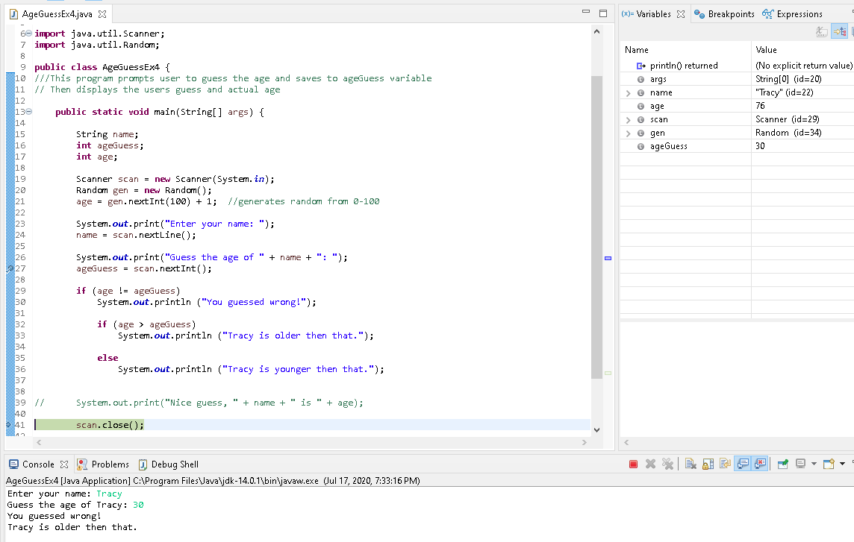

# Exercise 5

Make a Java program called FloatEqu.java and implement the following:

1. Declare a double variable and initialize it to(1.0/10) * (1.0/10)

Declare another double variable and initialize it to(1.0/100)

Insert an if … else statement and print out "EQUAL" if both variables are equal (use ==) and "NOT EQUAL" otherwise. Run the program and check the output. Is it what you would expect?

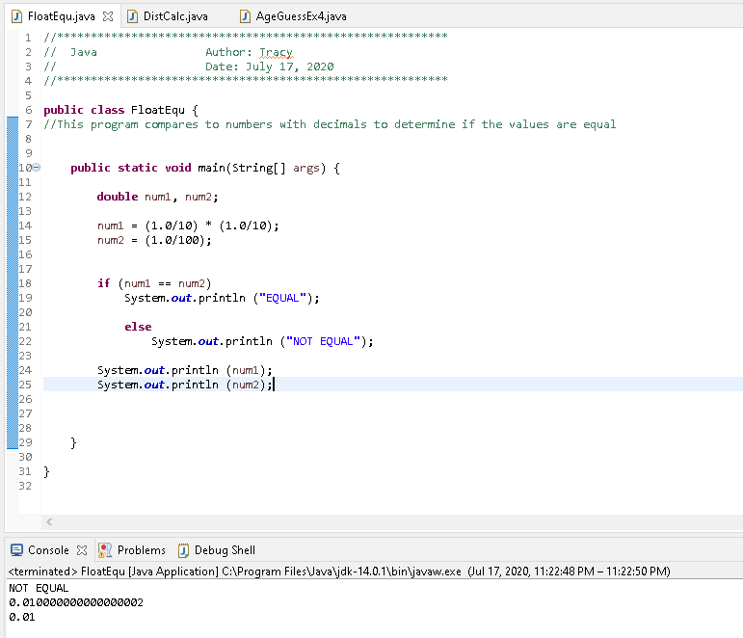

1. Modify the program by adding a conditional statement to determine if the variables are approximately equal, using the approach discussed in the lecture.

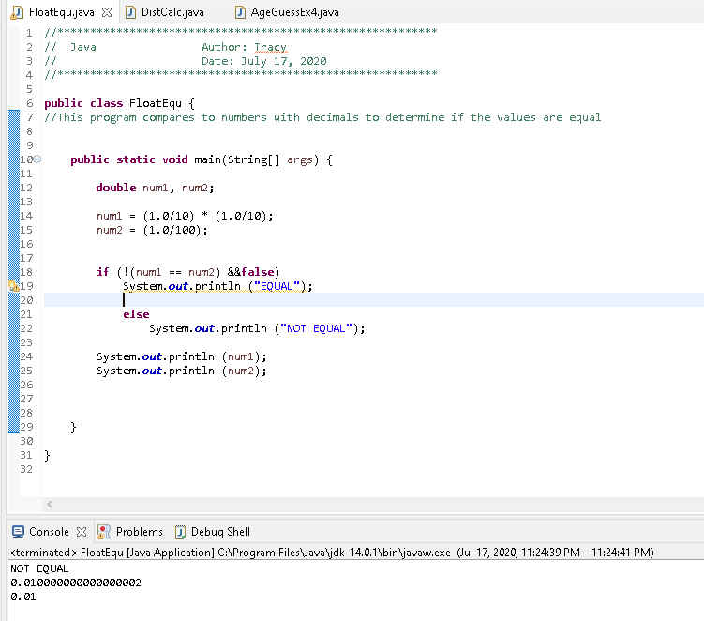

# Exercise 6

Make a program called NumDisplay.java that prompts the user enter a number between 0 and 9 and then display the corresponding word (i.e. "zero" for 0, "one" for 1, etc.). Use a switch statement to do this. Include a default case that lets the user know they entered a wrong number.

